Magnezium anodes ANODE RODS protecting water heater from corrosion

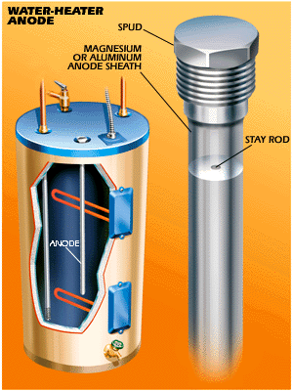
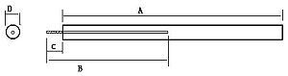
THREAD M8, 3/4“, 1“

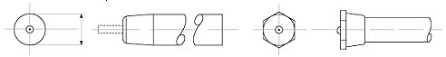
THREAD 3/4", 1“

Mg cast rod anode are normally use in protecting water heater from corrosion. We, supply supper quality Mg cast rod anode as follows:
Mg Cast Rod Anode----AZ63
Chemical composition %

Alloy | Al | Zn | Mn | Si  (max) | Cu  (max) | Ni  (max) | Fe  (max) | Total of Impurities(max)
AZ63B | 5.30-6.70 | 2.50-3.50 | 0.15-0.70 | 0.10 | 0.02 | 0.002 | 0.003 | 0.30

Mg Extruded Rod

Extruded anodes have high current to weight ratio, are suitable to be used in where a small diameter anode is required to give enough cathodic current. We supply extruded anodes in both high potential (Mg-Mn alloy) and low potential (AZ31 alloy). Our extruded anodes are typically suitable for all kinds of water heaters and water storage tanks.

Chemical composition %

Alloy | Al | Mn | Zn  (max) | Ca  (max) | Si  (max) | Cu  (Max) | Ni  (max) | Fe  (max) | Other Imp.
 |  |  |  |  |  |  |  |  | each | total
AZ31B | 2.5-3.5 | 0.2-1.0 | 0.6-1.4 | 0.04 | 0.10 | 0.03 | 0.005 | 0.005 | --- | 0.30

We supply anode rods in accordance with your dimension requirement

Telephone : 575570504, 603 436 680, Fax575570505

Electronic mail : suntoc@suntoc.cz

Postal address : VTP servis Zlín s.r.o. Chmelnická 445 761 36 Zlín-Prštné
Czech Republic

